 | Sheraton Boston Hotel & Towers | Sheraton Newton Hotel
 | 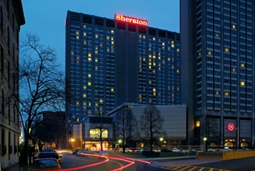 | 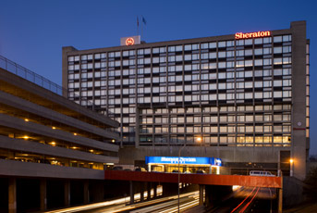
This may be the hotel for you if | You are planning to visit Boston during your stay.  You want to stay at a hotel in the city.  You prefer convenient access to the subway over a low parking rate.  A location within easy walking distance of sites, shops, and restaurants will contribute significantly to your enjoyment of the weekend. | You are planning to drive to all of your destinations.  You want to stay at a hotel outside the city.  You prefer a low parking rate over convenient access to the subway.  A $99 room rate will contribute significantly to your enjoyment of the weekend.
Address | 39 Dalton Street  Boston, MA 02199 | 320 Washington Street  Newton, MA 02458
Discounted room rate | $209 per night, plus 12.45% tax  $40 for each additional adult above two | $99 per night, plus 9.7% tax  Four adults per room allowed at this rate
Early departure fee | $75 | $0; 24-hour notice required
Nights included | Friday and Saturday | Thursday, Friday, and Saturday
Hotel parking | $41 per day | $12 per day
Rewards category | Starwood Preferred Guest Category 4 | Starwood Preferred Guest Category 3
Distance to ceremony | 4.9 miles, 17 minutes without traffic | 3.0 miles, 9 minutes without traffic
Distance from reception | 1.2 miles, 6 minutes without traffic | 6.9 miles, 16 minutes without traffic
Distance to Sunday breakfast for traveling guests | Easy walk; breakfast will be held at or near the hotel | 6.6 miles, 12 minutes without traffic
Highway access | Mass Pike (I-90) Exit 22  0.4 miles, 2 minutes without traffic | Mass Pike (I-90) Exit 17  0.5 miles, 2 minutes without traffic
Public transportation | Close to Prudential and Hynes subway stops  Adult fare: $1.70 with Charlie Card  Children under 11 ride free with adult | Close to 504 and 553 bus routes  Adult fare: Starting at $2.80 with Charlie Card  Children under 11 ride free with adult

