ASSIGNMENT THREE

This assignment has two parts.

PART ONE

Introduction (to be read carefully)
One of the goals of this course is to see how economics contributes to the understanding of history. The study of history is worthwhile when it supersedes the mere account of facts and anecdotes, and uncovers mechanisms that are independent of individuals. In this task, economics, which rests on optimization under constraints, is a particularly useful tool. (Such optimization is found in many domains of nature, including the animal world). The analysis of mechanisms has emphasized by historians outside of the field of economics as suggested by the following short text. The purpose of question 1 in this assignment is to consider an important event, the battle of Crécy in 1346. That battle, together with a near repeat at Poitiers ten years after, established the victory of England in the first half of the Hundred Years war.
A superb work is The Welsh Wars of Edward I published in 1901. It is still a model today and was reprinted in 1996 with the following foreword of Michael Prestwhich (possibly the best specialist of Edward I today):
“J.E. Morris’ The Welsch Wars of Edward I is a truly pioneering work. It was first published in 1901, and it was not for many years that other scholars began to approach the subject in the way Morris did. Not content to limit himself to the conventional questions of military history, those about battles, strategy and tactics, he first of all examined the structures that underlay the triumphs achieved by Edward I in Wales.”
Now, what was the inspiration for Morris? He explains himself at the very outset of his preface
“If it be true that the English learnt on the battlefields of Scotland the experience which was destined to make them the victors at Crecy and Poitiers, it is equally true that the preliminary experience had been learnt in Wales. It was precisely because I wanted to trace back the evolution of the typically english combination of knights with archers beyond the battle of Falkirk, which is usually considered to have been the first great victory of the longbow, that I began to study the documents of the Welsh wars. The period, rather more than eighteen years, is of peculiar interest. The rolls are tolerably exhaustive; we have minute details concerning the men in the king’s pay in most of his armies, besides evidence which enables us to conjecture the strength of others. Feudal and paid troops are found fighting side by side”.
You see the approach: an event which has been the focus of many standard accounts and for good reasons: it was a pivotal event. But Morris goes back to roots of the event and uses the hard evidence of accounting documents about public expenditures in a period that started seventy years before.

So far in this course, we have seen three main types of public finances, Egypt, the Roman empire and feudalism. In regard to the last one, the lectures emphasized that feudalism is essentially an adaptation of the public finances (always for military purpose before 1815) to the conditions of information and enforcement in the Middle Ages. A statement to which I subscribe wholeheartedly and that you should read and re-read, is the following summary by J. Strayer, who was one of the important figures in 20th century medieval studies.
“The basic characteristics of feudalism in Western Europe are a fragmentation of political authority, public power in private hands, and a military system in which an essential part of the armed forces is secured through private contracts. Feudalism is a method of government, and a way of securing the forces necessary to preserve that method of government.
This is not as narrow a definition as it seems. The possessors of political and military power will naturally model their society to fit their own needs. They will manipulate the economy so that they get the greatest share of production; they will, as wealthy consumers, influence writers and artists; they will establish standards to which their society must conform. Thus, it is perfectly legitimate to speak of feudal society, or a feudal age, if we remember that it was the polticial-military structure which made the society and the age feudal.
On the other hand, if we try a wider definition, feudalism becomes an amorphous term. The most usual attempt to broaden the definition of feudalism stresses social and economic factors; in its simplest form it would find the essence of feudalism in the exploitations of an agricultural population by a ruling group. That this occurred in the feudal society of Western europe is certainly true; it is equally true that it occurred in many other societies as well, both before and after the Middle Ages. nor can we say that this situation is typical of all pre-industrial societies, and that therefore the socioeconomic definition of feudalism is useful in marking a universal stage of economic development... A definition which can include societies as disparate as those of the Ancient Middle East, the late Roman Empire, medieval Europe, the southern part of the United states in the nineteenth century, and the Soviet Union in the 1930s is not much use in historical analysis.”
The battle of Crécy is a critical event in feudalism (as defined by Strayer). At the time of the battle, the armies, technologies and strategies were set. Their forms had been shaped for the most part by the public finances in England and France and the evolutions of feudalism on the two sides of the Channel. This issue is the focus on the assignment.
We don’t have the time here for a detailed comparative study of the evolution of feudalism (Strayer) in England and France using available documents as Morris. However, we should emphasize contemporary evidence. One revealing accounts of the battle has been provided by Froissart. He was 9 years old at the time of the battle and wrote his book 13 years after the event. It is like you writing about the first war in Irak. Froissart is not always accurate, for example about the number of participants and dead, but these details do not matter for us here.
Assignment in Part One
- Make sure you are familiar with the basic historical facts of the time. The short summary of the battle in Wikipédia is useful but does not address the issues of the assignment.
- Have a first reading of the account of Froissart, attached at the end of the assignment. In that reading, you may also appreciate the individuals’ attitudes and behaviors at the time. I made minor corrections on a text that is in the public domain on the web.
- After a second reading, answer the following question (Not more than two pages. A very good and accurate argument could fit in one page-single space).
Identify the details in the battle (composition of the armies, strategies, individual motivations and decisions, events which seemed random and beyond control that day), which are direct consequences of the different evolutions of feudalisms in the two parties, as presented in the lecture. A central point is the evolution of the feudal dues in England and France, respectively. Be as accurate and as close to the text as you can. Use, without excess, short quotations to illustrate your argument.

The Chronicles of Froissart
JEAN FROISSART, the most representative of the chroniclers of the later Middle Ages, was born at Valenciennes in 1337. The Chronicle which, more than his poetry, has kept his fame alive, was undertaken when he was only twenty; the first book was written in its earliest form by 1369; and he kept revising and enlarging the work to the end of his life. In 1361 he went to England, entered the Church, and attached himself to Queen Philippa of Hainault, the wife of Edward III, who made him her secretary and clerk of her chapel. Much of his life was spent in travel. He went to France with the Black Prince, and to Italy with the Duke of Clarence. He saw fighting on the Scottish border, visited Holland, Savoy, and Provence, returning at intervals to Paris and London. He was Vicar of Estinnes-au-Mont, Canon of Chimay, and chaplain to the Comte de Blois; but the Church to him was rather a source of revenue than a religious calling. He finally settled down in his native town, where he died about 1410.
OF THE ORDER OF THE ENGLISHMEN AT CRESSY, AND HOW THEY MADE THREE BATTLES AFOOT (http://www.luminarium.org/encyclopedia/crecyfroissart.htm)
On the Friday, as I said before, the king of England lay in the fields, for the country was plentiful of wines and other victual, and if need had been, they had provision following in carts and other carriages. That night the king made a supper to all his chief lords of his host and made them good cheer; and when they were all departed to take their rest, then the king entered into his oratory and kneeled down before the altar, praying God devoutly, that if he fought the next day, that he might achieve the journey to his honour: then about midnight he laid him down to rest, and in the morning he rose betimes and heard mass, and the prince his son with him, and the most part of his company were confessed and houselled; and after the mass said, he commanded every man to be armed and to draw to the field to the same place before appointed. Then the king caused a park to be made by the wood side behind his host, and there was set all carts and carriages, and within the park were all their horses, for every man was afoot; and into this park there was but one entry. Then he ordained three battles: in the first was the young prince of Wales, with him the earl of Warwick and Oxford, the lord Godfrey of Harcourt, sir Raynold Cobham, sir Thomas Holland, the lord Stafford, the lord of Mohun, the lord Delaware, sir John Chandos, sir Bartholomew de Burghersh, sir Robert Nevill, the lord Thomas Clifford, the lord Bourchier, the lord de Latimer, and divers other knights and squires that I cannot name: they were an eight hundred men of arms and two thousand archers, and a thousand of other with the Welshmen: every lord drew to the field appointed under his own banner and pennon. In the second battle was the earl of Northampton, the earl of Arundel, the lord Ros, the lord Lucy, the lord Willoughby, the lord Basset, the lord of Saint-Aubin, sir Louis Tufton, the lord of Multon, the lord Lascelles and divers other, about an eight hundred men of arms and twelve hundred archers. The third battle had the king: he had seven hundred men of arms and two thousand archers. Then the king leapt on a hobby, with a white rod in his hand, one of his marshals on the one hand and the other on the other hand: he rode from rank to rank desiring every man to take heed that day to his right and honour. He spake it so sweetly and with so good countenance and merry cheer, that all such as were discomfited took courage in the seeing and hearing of him. And when he had thus visited all his battles, it was then nine of the day: then he caused every man to eat and drink a little, and so they did at their leisure. And afterward they ordered again their battles: then every man lay down on the earth and by him his salet and bow, to be the more fresher when their enemies should come.
This Saturday the French king rose betimes and heard mass in Abbeville in his lodging in the abbey of Saint Peter, and he departed after the sun-rising. When he was out of the town two leagues, approaching toward his enemies, some of his lords said to him: 'Sir, it were good that ye ordered your battles, and let all your footmen pass somewhat on before, that they be not troubled with the horsemen.' Then the king sent four knights, the Moine [of] Bazeilles, the lord of Noyers, the lord of Beaujeu and the lord d'Aubigny to ride to aview the English host; and so they rode so near that they might well see part of their dealing. The Englishmen saw them well and knew well how they were come thither to aview them: they let them alone and made no countenance toward them, and let them return as they came. And when the French king saw these four knights return again, he tarried till they came to him and said: 'Sirs, what tidings?' These four knights each of them looked on other, for there was none would speak before his companion; finally the king said to [the] Moine, who pertained to the king of Bohemia and had done in his days so much, that he was reputed for one of the valiantest knights of the world: 'Sir, speak you.' Then he said: 'Sir, I shall speak, sith it pleaseth you, under the correction of my fellows. Sir, we have ridden and seen the behaving of your enemies: know ye for truth they are rested in three battles abiding for you. Sir, I will counsel you as for my part, saving your displeasure, that you and all your company rest here and lodge for this night: for or they that be behind of your company be come hither, and or your battles be set in good order, it will be very late, and your people be weary and out of array, and ye shall find your enemies fresh and ready to receive you. Early in the morning ye may order your battles at more leisure and advise your enemies at more deliberation, and to regard well what way ye will assail them; for, sir, surely they will abide you.'
Then the king commanded that it should be so done. Then his two marshals one rode before, another behind, saying to every banner: 'Tarry and abide here in the name of God and Saint Denis.' They that were foremost tarried, but they that were behind would not tarry, but rode forth, and said how they would in no wise abide till they were as far forward as the foremost: and when they before saw them come on behind, then they rode forward again, so that the king nor his marshals could not rule them. So they rode without order or good array, till they came in sight of their enemies: and as soon as the foremost saw them, they reculed then aback without good array, whereof they behind had marvel and were abashed, and thought that the foremost company had been fighting. Then they might have had leisure and room to have gone forward, if they had list: some went forth and some abode still. The commons, of whom all the ways between Abbeville and Cressy were full, when they saw that they were near to their enemies, they took their swords and cried: 'Down with them! let us slay them all.' There is no man, though he were present at the journey, that could imagine or shew the truth of the evil order that was among the French party, and yet they were a marvellous great number. That I write in this book I learned it specially of the Englishmen, who well beheld their dealing; and also certain knights of sir John of Hainault's, who was always about king Philip, shewed me as they knew.
The Englishmen, who were in three battles lying on the ground to rest them, as soon as they saw the Frenchmen approach, they rose upon their feet fair and easily without any haste and arranged their battles. The first, which was the prince's battle, the archers there stood in manner of a herse and the men of arms in the bottom of the battle. The earl of Northampton and the earl of Arundel with the second battle were on a wing in good order, ready to comfort the prince's battle, if need were.
The lords and knights of France came not to the assembly together in good order, for some came before and some came after in such haste and evil order, that one of them did trouble another. When the French king saw the Englishmen, his blood changed, and said to his marshals: 'Make the Genoways go on before and begin the battle in the name of God and Saint Denis.' There were of the Genoways cross-bows about a fifteen thousand,
[Note: Villani, a very good authority on the subject, says 6000, brought from the ships at Harfleur.]
But they were so weary of going afoot that day a six leagues armed with their cross-bows, that they said to their constables: 'We be not well ordered to fight this day, for we be not in the case to do any great deed of arms: we have more need of rest.' These words came to the earl of Alencon, who said: 'A man is well at ease to be charged with such a sort of rascals, to be faint and fail now at most need.' Also the same season there fell a great rain and a flash of lightning with a terrible thunder, and before the rain there came flying over both battles a great number of crows for fear of the tempest coming. Then anon the air began to wax clear, and the sun to shine fair and bright, the which was right in the Frenchmen's eyen and on the Englishmen's backs. When the Genoways were assembled together and began to approach, they began to utter cries so loud it was wonderful. They did this to abash the Englishmen, but the Englishmen stood still and stirred not for all that: then the Genoese again the second time made another cry, and stepped forward a little, and the Englishmen removed not one foot: thirdly, again they leapt and cried, and went forth till they came within shot; then they shot fiercely with their cross-bows. Then the English archers stept forth one pace and let fly their arrows so wholly [together] and so thick, that it seemed snow. When the Genoese felt the arrows piercing through heads, arms and breasts, many of them cast down their cross-bows and did cut their strings and returned discomfited. When the French king saw them fly away, he said: 'Slay these rascals, for they shall let and trouble us without reason.' Then ye should have seen the men of arms dash in among them and killed a great number of them: and ever still the Englishmen shot whereas they saw thickest press; the sharp arrows ran into the men of arms and into their horses, and many fell, horse and men, among the Genoese, and when they were down, they could not stand up again, the press was so thick that one overthrew another. And also among the Englishmen there were certain rascals that went afoot with great knives, and they went in among the men of arms, and slew and murdered many as they lay on the ground, both earls, barons, knights and squires, whereof the king of England was after displeased, for he had rather they had been taken prisoners.
The valiant king of Bohemia called Charles of Luxembourg, son to the noble emperor Henry of Luxembourg, for all that he was nigh blind, when he understood the order of the battle, he said to them about him: 'Where is the lord Charles my son?' His men said: 'Sir, we cannot tell; we think he be fighting.' Then he said: 'Sirs, ye are my men, my companions and friends in this journey: I require you bring me so far forward, that I may strike one stroke with my sword.' They said they would do his commandment, and to the intent that they should not lose him in the press, they tied all their reins of their bridles each to other and set the king before to accomplish his desire, and so they went on their enemies. The lord Charles of Bohemia his son, who wrote himself king of Almaine and bare the arms, he came in good order to the battle; but when he saw that the matter went awry on their party, he departed, I cannot tell you which way. The king his father was so far forward that he strake a stroke with his sword, yea and more than four, and fought valiantly and so did his company; and they adventured themselves so forward, that they were there all slain, and the next day they were found in the place about the king, and all their horses tied each to other.
The earl of Alencon came to the battle right ordinately and fought with the Englishmen, and the earl of Flanders also on his part. These two lords with their companies coasted the English archers and came to the prince's battle, and there fought valiantly long. The French king would fain have come thither, when he saw their banners, but there was a great hedge of archers before him. The same day the French king had given a great black courser to sir John of Hainault, and he made the lord Tierry of Senzeille to ride on him and to bear his banner. The same horse took the bridle in the teeth and brought him through all the currours of the Englishmen, and as he would have returned again, he fell in a great dike and was sore hurt, and had been there dead, an his page had not been, who followed him through all the battles and saw where his master lay in the dike, and had none other let but for his horse, for the Englishmen would not issue out of their battle for taking of any prisoner. Then the page alighted and relieved his master: then he went not back again the same way that they came, there was too many in his way.
This battle between Broye and Cressy this Saturday was right cruel and fell, and many a feat of arms done that came not to my knowledge. In the falling night divers knights and squires lost their masters, and sometime came on the Englishmen, who received them in such wise that they were ever nigh slain; for there was none taken to mercy nor to ransom, for so the Englishmen were determined.
In the morning
[Note: The text has suffered by omissions. What Froissart says is that if the battle had begun in the morning, it might have gone better for the French, and then he instances the exploits of those who broke through the archers. The battle did not begin till four o'clock in the afternoon.]
the day of the battle certain Frenchmen and Almains perforce opened the archers of the prince's battle and came and fought with the men of arms hand to hand. Then the second battle of the Englishmen came to succour the prince's battle, the which was time, for they had as then much ado; and they with the prince sent a messenger to the king, who was on a little windmill hill. Then the knight said to the king: 'Sir, the earl of Warwick and the earl of Oxford, sir Raynold Cobham and other, such as be about the prince, your son, are fiercely fought withal and are sore handled; wherefore they desire you that you and your battle will come and aid them; for if the Frenchmen increase, as they doubt they will, your son and they shall have much ado.' Then the king said: 'Is my son dead or hurt or on the earth felled?' 'No, sir,' quoth the knight, 'but he is hardly matched; wherefore he hath need of your aid.' 'Well" said the king, 'return to him and to them that sent you hither, and say to them that they send no more to me for any adventure that falleth, as long as my son is alive: and also say to them that they suffer him this day to win his spurs;
for if God be pleased, I will this journey be his and the honour thereof, and to them that be about him.' Then the knight returned again to them and shewed the king's words, the which greatly encouraged them.
Sir Godfrey of Harcourt would gladly that the earl of Harcourt his brother might have been saved; for he heard say by them that saw his banner how that he was there in the field on the French party: but sir Godfrey could not come to him betimes, for he was slain or he could come at him, and so was also the earl of Aumale his nephew. In another place the earl of Alencon and the earl of Flanders fought valiantly, every lord under his own banner; but finally they could not resist against the puissance of the Englishmen, and so there they were also slain, and divers other knights and squires. Also the earl Louis of Blois, nephew to the French king, and the duke of Lorraine fought under their banners, but at last they were closed in among a company of Englishmen and Welshmen, and there were slain for all their prowess. Also there was slain the earl of Auxerre, the earl of Saint-Pol and many other.
In the evening the French king, who had left about him no more than a three-score persons, one and other, whereof sir John of Hainault was one, who had remounted once the king, for his horse was slain with an arrow, then he said to the king: 'Sir, depart hence, for it is time; lose not yourself wilfully: if ye have loss at this time, ye shall recover it again another season.' And so he took the king's horse by the bridle and led him away in a manner perforce. Then the king rode till he came to the castle of Broye. The gate was closed, because it was by that time dark: then the king called the captain, who came to the walls and said: 'Who is that calleth there this time of night?' Then the king said: 'Open your gate quickly, for this is the infortunate king of France.' The captain knew then it was the king, and opened the gate and let down the bridge. Then the king entered, and he had with him but five barons, sir John of Hainault, sir Charles of Montmorency, the lord of Beaujeu, the lord d'Aubigny and the lord of Montsault. The king would not tarry there, but drank and departed thence about midnight, and so rode by such guides as knew the country till he came in the morning to Amiens, and there he rested.
This Saturday the Englishmen never departed from their battles for chasing of any man, but kept still their field, and ever defended themselves against all such as came to assail them. This battle ended about evensong time.
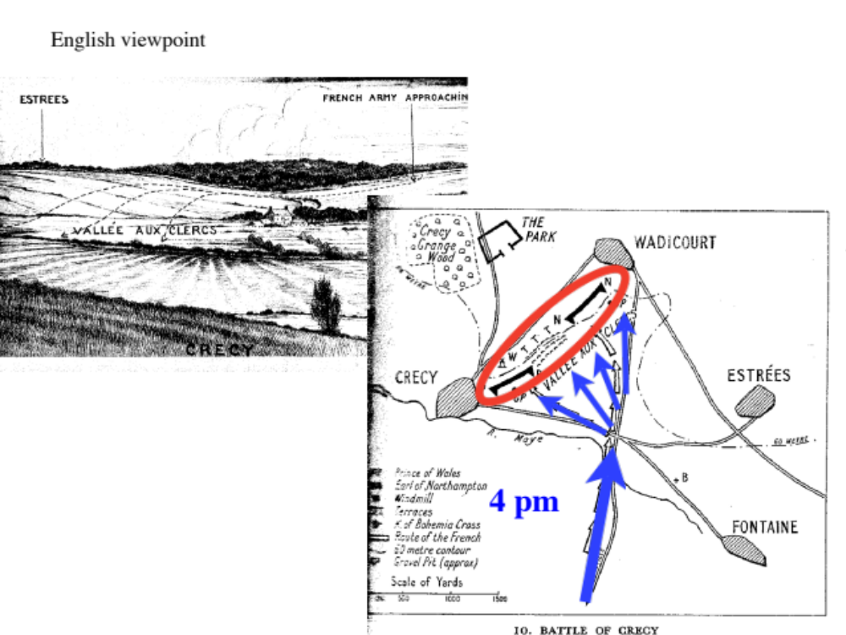

PART TWO

Assignment
- Make sure you are familiar with the basic historical facts of the time. The short summary of the battle in Wikipédia is useful but does not address the issues of the assignment.
- Have a first reading of the account of Froissart, attached at the end of the assignment. In that reading, you may also appreciate the individuals’ attitudes and behaviors at the time. I made minor corrections on a text that is in the public domain on the web.
- Read the introduction to De Moneta of Nicolas Oresme in . You may complement this information with a look at the Wikipedia note on Nicolas Oresme.
- Don’t be scared or puzzled by the Latin at the beginning. It is just given to remind you that everything scholarly was in Latin at the time (and more or less until the end of the 17th century, in England and in continental Europe).
- Read pages 4-7 (Chapter I, II, and part of Chapter III). Comment (about 10 lines) on these in view of what we have seen in this course.
- Read the end of Chapter II (p. 8). Do you think that Oresme is correct?
- Read Chapters V and VI. Comment on the view of Oresme about the role of the “prince” and the ownership of money (5 to 10 lines, as a non-binding indication).
- Using Chapters XVI, XVII, XXII, XXIII, and your previous answers, under what conditions, according to Oresme should seignorage be either prohibited as a crime or should be allowed?
- Read Chapter XXIV. Can one say that the economic analysis of money by Oresme provides a basis for the presentation of his view on the role of the “prince” in the middle 14th century?
- (optional) Is the second paragraph of Chapter XX (p. 32) correct for a modern economist? Can it be correct for the economy in which Oresme operated?

